Bench Sales Recruiting — Phased Implementation Plan
Status: Draft · Version: 0.1 · Date: 2 June 2026 · Companion to the MVP Scope document.

Approach: walking skeleton, then deepen
Wire the whole loop end-to-end first, with the crudest valid implementation of every stage, then make one slice real per phase. The point is to surface integration problems — the contracts between stages, the data shapes, the pgvector wiring — on day one rather than at the end.
The invariant: at the end of every phase, the entire loop runs end-to-end. You never hold a half-connected system; you hold a working system that is getting less crude. If a phase would break the loop, it is scoped wrong — split it.
Two progress signals, both objective: component maturity (the matrix below) and per-phase exit criteria. Both lean on the scaffold's test suite and eval harness rather than on judgement.

Maturity levels
- ▢ Stub — returns valid, typed output; no real logic. Exists only to keep the loop wired.
- ◐ Basic — real but crude or heuristic; good enough to exercise the loop honestly.
- ● Real — MVP-quality, per the scope document.
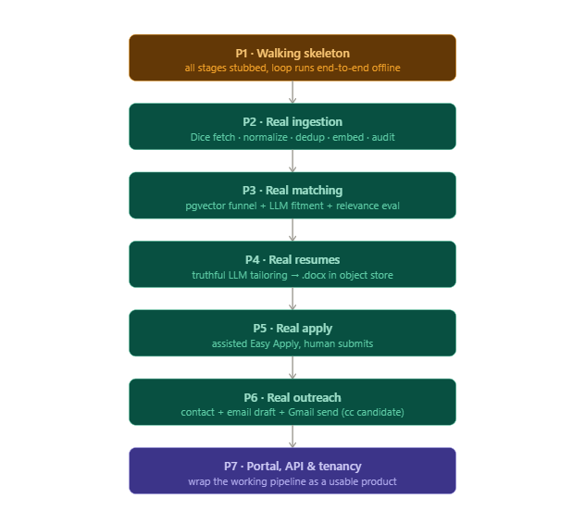

Phase 1 — Walking skeleton
Goal: prove every contract and the wiring. One candidate flows from profile to a tracked application, fully offline, with the loop driven by a single command.
Becomes real: the data spine (Postgres + pgvector schema, including recruiter_id tenancy keys from the start), config, object storage, candidate intake (load profile + a trivial vector), a pipeline runner that sequences the stages, and tracking (reads the rows back).
Stays crude (stub/basic): ingestion serves fixtures; retrieval returns filtered fixtures with no real vector math; scoring is a keyword-overlap heuristic; tailoring copies a template .docx; contact returns the posting email or null; email produces a templated string with no send; apply just inserts an Application row with no browser.
Depends on: Postgres + pgvector, the existing scaffold.
Exit criteria: run --candidate cand_001 persists a candidate, jobs, scores, a resume file, and an application, and prints its status — all offline. The scaffold's pure tests are green (profile, normalize, store, eval, audit, contacts).
Checklist:
- [ ] Schema migrations incl. recruiter_id keys; pgvector extension enabled
- [ ] Object storage wired (local dir is fine)
- [ ] Pipeline runner (CLI or one endpoint) sequences all stages
- [ ] Every stub returns a valid model object
- [ ] One fixture candidate seeded; smoke run documented in the README

Phase 2 — Real ingestion (+ quality)
Goal: real, deduped, embedded postings in the store.
Becomes real: fetch_jobs (one real Dice pull — capture a real payload and replace the illustrative fixture), normalize (emit embed_text, content_hash, apply_type, and the three timestamps), dedup, real posting embeddings upserted into pgvector, and audit_quality.
Stays crude: matching, scoring, tailoring, apply, email remain stub/basic.
Exit criteria: a fetch produces real normalized postings; the audit reports completeness, dedup rate, freshness, and Easy-Apply share; the loop still runs end-to-end on real jobs.
Checklist:
- [ ] Replace raw_dice_response.json with a real capture; normalize handles the real shape
- [ ] Dedup verified (exact id + content_hash); reposts update last_seen/posted_date
- [ ] Posting embeddings stored in pgvector
- [ ] Audit numbers reviewed — especially Easy-Apply share, which informs apply scope

Phase 3 — Real matching
Goal: a genuinely relevant, fresh, not-yet-applied shortlist.
Becomes real: candidate embeddings (upgraded from trivial), the retrieval pgvector funnel (freshness window + per-candidate applied-exclusion + scope filter), score_fitment (LLM), and eval_relevance wired to a labeled set.
Stays crude: tailoring, apply, email remain stub/basic.
Exit criteria: retrieval excludes applied and out-of-window postings; LLM scores order obviously-good above obviously-bad; precision@k on the labels clears the bar set in the POC; loop runs end-to-end with real matches.
Checklist:
- [ ] Candidate vector is real and refreshes on profile change
- [ ] Single pgvector query with all three prefilter predicates
- [ ] Applied-exclusion is per-candidate
- [ ] Top-K handed to the LLM re-rank
- [ ] ~30–50 labeled pairs; precision@k / nDCG run and recorded

Phase 4 — Real resumes
Goal: truthful tailored resumes for top matches.
Becomes real: tailor_content (reframes real experience only) and render_docx; resumes written to object storage and linked to applications.
Exit criteria: generation runs best-fitment-first; the .docx opens cleanly; a spot-check confirms no fabricated experience; loop runs end-to-end.
Checklist:
- [ ] Truthful-reframe prompt with an explicit no-fabrication guardrail
- [ ] Clean .docx render
- [ ] Object-store paths recorded; resume linked to its Application

Phase 5 — Real apply (assisted)
Goal: the assisted-apply driver reaches a review-ready state on Easy Apply postings.
Becomes real: apply_driver — visible browser session, fills the Easy Apply form, attaches the resume, hard-stops before submit, records the outcome. Use a throwaway test account during development.
Exit criteria: reaches review-ready on Easy Apply postings; submitted_by reflects a human; fill-accuracy and correction-rate are measured; blockers are recorded; loop runs end-to-end.
Checklist:
- [ ] Browser tool wired (Playwright or Claude in Chrome)
- [ ] Field-fill + resume attach logic
- [ ] Submit control is not in the automation's action set
- [ ] CAPTCHA / anti-bot recorded as blockers, never bypassed
- [ ] ApplyOutcome persisted with fill metrics

Phase 6 — Real outreach
Goal: a posting-specific cold email, sent from the recruiter.
Becomes real: resolve_contact; draft_cold_email (truthful, specific to the posting); Gmail OAuth send with the candidate cc'd; an Outreach record logged. (Gated on the draft-vs-send open question — if draft-only is chosen, stop before send.)
Exit criteria: contact hit-rate measured; the recruiter reviews the draft; send goes through the recruiter's Gmail with the candidate cc'd and is logged; loop runs end-to-end.
Checklist:
- [ ] Contact resolver + manual-entry fallback
- [ ] Email draft prompt (truthful, posting-specific)
- [ ] Gmail OAuth; candidate cc'd; send logged as Outreach

Phase 7 — Portal, API & tenancy
Goal: turn the working pipeline into a usable product.
Becomes real: the backend API (auth, server-side tenancy enforcement, orchestration endpoints), the web portal (candidate list, job/match views, resume review, application tracker, email composer), and a live tracking dashboard. The portal replaces the CLI runner as the entry point.
Exit criteria: a recruiter completes the full loop from the UI; a recruiter cannot see another recruiter's data; tracking reads live.
Checklist:
- [ ] Auth + per-query tenancy enforcement
- [ ] Endpoints wrap the existing pipeline triggers
- [ ] Portal views for the full loop
- [ ] Live tracker; end-to-end UI demo

Maturity matrix (your tracker)
Each cell is the component's maturity at the end of that phase. Flip cells as you go; the picture fills toward Real (●) from the bottom-right.
Component | P1 | P2 | P3 | P4 | P5 | P6 | P7
Data spine (PG + pgvector) | ● | ● | ● | ● | ● | ● | ●
Pipeline runner | ● | ● | ● | ● | ● | ● | ●
Candidate intake | ◐ | ◐ | ● | ● | ● | ● | ●
Job ingestion | ▢ | ● | ● | ● | ● | ● | ●
Quality audit | – | ● | ● | ● | ● | ● | ●
Retrieval (funnel) | ▢ | ▢ | ● | ● | ● | ● | ●
Fitment scoring | ▢ | ▢ | ● | ● | ● | ● | ●
Resume tailoring | ▢ | ▢ | ▢ | ● | ● | ● | ●
Contact resolution | ◐ | ◐ | ◐ | ◐ | ◐ | ● | ●
Cold email | ▢ | ▢ | ▢ | ▢ | ▢ | ● | ●
Assisted apply | ▢ | ▢ | ▢ | ▢ | ● | ● | ●
Tracking | ◐ | ◐ | ◐ | ◐ | ◐ | ◐ | ●
API + tenancy | – | – | – | – | – | – | ●
Portal | – | – | – | – | – | – | ●

Tracking convention
- Keep the matrix current — it is the single glanceable view of where things stand.
- A phase's exit criteria are the gate to the next phase. Do not advance with a broken loop.
- Let the objective signals carry the weight: which scaffold tests are green, precision@k at P3, fill-accuracy at P5, contact hit-rate at P6.
- Add a one-line status per phase as you go: Not started / In progress / Done + date.

Sequencing rationale
- Inputs before actions. Matching and resumes become real (P3–P4) before apply and outreach (P5–P6), so you test the risky actions with realistic artifacts, not stub data.
- Riskiest external action after its inputs are real. Assisted apply (P5) follows good matches and good resumes, so a failure is a driver problem, not a garbage-in problem.
- UI last. The portal (P7) wraps a pipeline that already works, rather than being built over a moving target.
- Tenancy keys early, enforcement late. recruiter_id lands in the schema at P1 even though the API enforces it at P7 — cheap now, painful to retrofit.

Dependencies on open questions
- Tenancy (multi vs. single): affects the P1 schema keys and P7 enforcement — resolve before P1 settles.
- Email send vs. draft-only: affects whether P6 includes the Gmail/OAuth work — resolve before P6.
- Freshness window length: a config value used at P3 — non-blocking.

